TRENDS IN GASTROPOD DRILLING OF BIVALVES

MAYA ORTIZ
Yale University, Yale Peabody Museum, New Haven, Connecticut, 06511, USA
email: maya.ortiz@yale.edu

ABSTRACT: Drilling gastropods leave distinguishable holes in their bivalve prey allowing drill attempts to be traced through the fossil record and into the modern day. Examining drill holes on bivalves gives insight into trends in drilling predation between gastropods and bivalves over time and trends in predator-prey relationships broadly. In this study, I investigated whether the size of gastropod predators and the size of bivalve prey influenced prey selection. I hypothesized a linear directly proportional relationship between drill hole size and bivalve size. I also aimed to discover a relationship between the location of gastropod drilling on bivalves and the location of the soft organs in bivalves. I hypothesized that gastropod predators would drill at the center of bivalves to access the soft organs. I evaluated the relationship between bivalve and gastropod size by measuring drilled fossil and modern valves at their longest and widest points and compared those measurements to the diameter of their drill holes. I evaluated hole location by categorizing drill holes into four quadrant locations on modern and fossilized valves. Drill holes in bivalves were primarily located in the half of valves closest to the hinge disputing my hypothesis. However, gastropods appear to maximize the efficiency of drilling predation by drilling in the lower two quadrants where soft organs occupy the most space. There was a logarithmic relationship between drill hole diameter and the length and width of bivalves showing that larger gastropods prey on larger bivalves and smaller gastropods prey on smaller bivalves despite the predator-prey size ratio between gastropods and bivalves increasing as prey size decreases. This trend reflects a larger trend in predator-prey relationships where larger predators prey on larger and smaller prey.

INTRODUCTION
Drilling predation is a chemical and mechanical process whereby carnivorous gastropods use their radula and accessory boring organs to drill holes through the calcareous shells of bivalves and gastropods to consume the internal soft organs (Carriker and Gruber 1999). This method of predation leaves preservable diagnostic holes in prey that allow drill attempts to be traced through the fossil and into the modern record. Records of drill holes from Muricidae and Naticidae, the two families primarily attributed to gastropod drilling (Kelley and Hansen 2003), can be traced back to the Mesozoic era (Harper et al. 1998; Newton 1983).
Drill holes left by naticids are distinguishable by their beveled circular structure, while drill holes left by muricids are typically smaller and more cylindrical (Kelley and Hansen 2003). Drill hole size is directly proportional to the size of the drilling gastropod (Kowalewski 2004). Holes that resemble complete drill holes and do not penetrate a shell (incomplete drill holes) are sites of unsuccessful predation attempts. Incomplete drilling can occur as result of other predators interfering with drilling gastropods, bivalves escaping during predation or shells with increased thickness, as shell thickness elongates the drilling process which can take hours to days (Kitchell et al. 1981).
Multiple muricids can prey on victims simultaneously resulting in prey with multiple drill holes (Brown and Alexander 1994). Muricids can return to prey and complete incomplete drill holes if interrupted during the drilling process (Kelley and Hansen 2003). Shells with multiple successful drill holes typically result from simultaneously muricid drilling. Conversely, naticid predation prevents the drilling of simultaneous predators (Kitchell et al. 1986). Subsequently, naticids are unable to return to incomplete drill holes if interrupted during predation. If interrupted, naticids may return to their prey and drill in a new location of the shell (Kitchell et al. 1981). Therefore, shells with multiple unsuccessful drill holes or one successful attempt and one or more unsuccessful attempts would likely result from one or multiple naticids drilling in subsequent predation attempts (Kitchell et al. 1981) or from group drilling when muricids abandon their drill holes to consume their prey from complete holes (Dietl 2000).
In this study, I sought to evaluate trends in gastropod drilling of bivalves throughout the fossil record to better understand their predator-prey relationships. I investigated whether the size of gastropod predators and the size of bivalve prey influenced prey selection. I hypothesized that larger gastropods prey on larger bivalves and that smaller gastropods prey on smaller bivalves resulting in a directly proportional relationship between drill hole size and bivalve size. In this study, I also aimed to discover a relationship between the location of gastropod drilling on bivalves and the location of the soft organs in bivalves. I hypothesized that gastropod predators would drill at the center of bivalves to access the soft organs. I analyzed this by evaluating drill hole locations on bivalves.

METHODS
The study evaluated trends of gastropod drilling using a sample pool of fossilized and modern bivalves. The sample pool consisted of 93 samples of modern bivalves and 18 samples of fossilized bivalves from the Yale Peabody Museum’s Invertebrate Zoology and Paleontology collections. Each sample consisted of 1 to 443 valves (17 valves per sample on average) collected at the same time and location with at least one valve with a drill attempt. The sample pool was limited to bivalves with drill attempts in the Yale Peabody collections. Valves with drill attempts were identified in accordance with Kelley and Hansen’s (2003) descriptions of muricid and naticid drill holes.
The modern samples had a total of 1,608 valves, while the fossil samples included 306 valves. Fossil specimens range from the Miocene to the Quaternary, and modern specimens were collected between 1866 and 2022 (17% of samples did not have collection date data). The sample pool represents a range of localities and species under the class Bivalvia. Specimens were primarily collected in the United States but were found in a variety of places across Asia, Europe, Oceania, North America and South America.
I counted and recorded the number of valves, articulated specimens and drilled valves for each sample. I also recorded the taxonomic data of each sample alongside data on the sample’s collection date and location when location and date information was available. Valves with drill attempts were used for further data collection.
I measured and recorded the lengths and widths of valves with drill attempts in millimeters at the longest and widest points using Mitutoyo Electronic Calipers (0mm to 150mm and ±0.01mm resolution) or imaging technology to determine the size of prey (Fig. 1). Valves with a length or width approximately 10 mm or less were measured using images while valves with lengths and widths greater than 10 mm were measured with calipers. Photographs were taken of valves with differing scale bars using a Leica M205 C microscope with a Leica DMC4500 digital microscope camera microscope or a Canon EOS 5DSR DSLR camera with a Canon MP-E 65mm Macro Lens when images were used. For images, I measured the valves using Adobe Photoshop. Length or width values were not taken for valves broken to the extent that their lengths or widths at the widest points were deemed indeterminate. The number of drill attempts in a valve was also recorded.
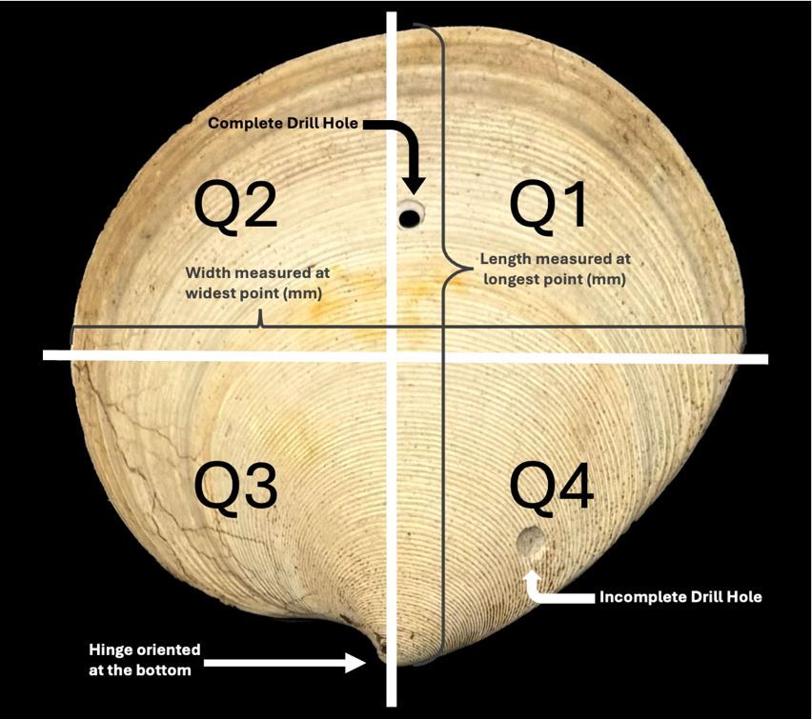
The diameter of each drill attempt was measured in mm at the widest point of the attempt to account for the beveled shape of muricid drills. Diameters were measured, like bivalve lengths and widths, using calipers or imaging technology. Drill attempts with diameters of approximately 1 mm or less were typically measured using imaging technology while diameters greater than 1 mm were typically measured with calipers. Each drill attempt was categorized as complete or incomplete depending on whether the drill attempt penetrated the valve. Lastly, I categorized drill attempts into four quadrants on the valve to record the drill location (Fig. 1). Quadrants were determined visually when drill attempts were clearly located in a quadrant; however, some quadrants were determined using calipers or imaging measurements when unable to be determined visually. Drill hole quadrants were determined by the center of the drill hole.
FIG. 1.— A fossilized specimen with a complete and incomplete drill hole. The valve is labeled as it was measured in the study.
The hinge of each valve was oriented at the bottom of the valve during length and width measurements as well as when quadrants were recorded for drill attempts to maintain consistent measurements between an array of bivalve genera (Fig. 1).
To determine a relationship between predator and prey size, I created two scatter plots in Microsoft Excel. One scatter plot plotted drill hole diameter over bivalve length, and the second, plotted drill hole diameter over bivalve width (Fig. 2). Trendlines of best fit were chosen for each scatter plot based on the highest R² value to reflect best fit. Bar graphs were made to represent incomplete and complete drill hole distribution between quadrants on all valves with drill attempts, only fossilized valves with drill attempts and only modern valves with drill attempts (Fig. 3).

RESULTS
A total of 312 valves in the sample pool were drilled (19% of total valves). There were 324 drill attempts in the sample pool as nine valves contained more than one drill attempt. One valve had four drill attempts— the maximum number of attempts in the sample pool.
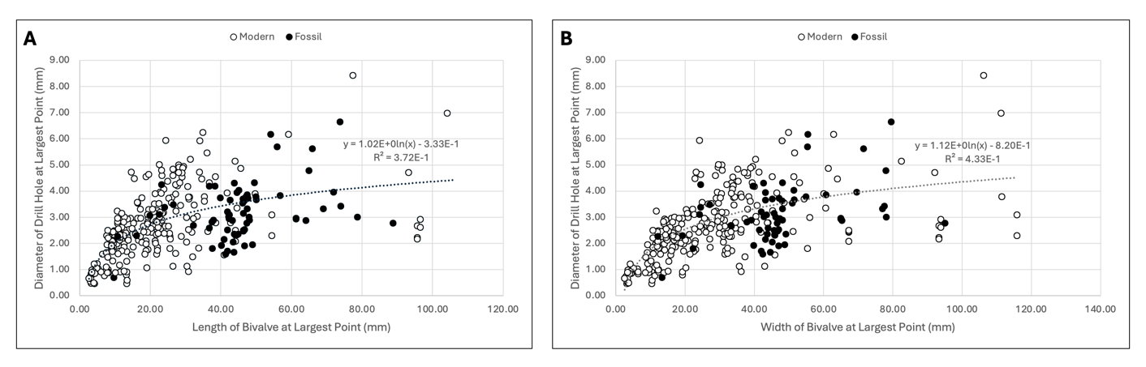
FIG. 2.— The graphs plot the diameter of drill holes in valves over the width and length of the drilled valves to show a logarithmic relationship between gastropod predator size, represented by drill hole size, and bivalve prey size, represented by the lengths and widths of bivalves.

There was a logarithmic relationship between length of bivalves and the drill hole diameter with an R² value of 0.372 (Fig. 2A). There was also a logarithmic relationship between width of bivalve and drill hole diameter with an R² value of 0.433 (Fig. 2B). As the diameter of drill holes increased, there was a general trend of bivalve length and widths increasing. Additionally, the drill hole size to bivalve length and width size was larger in bivalves with smaller lengths and widths than in valves with larger lengths and widths.
In the sample pool, 12% of drill attempts occurred in the first quadrant, 11% of attempts occurred in the second quadrant, 39% of drill attempts occurred in the third quadrant, and 39% of drill attempts occurred in the fourth quadrant (Fig. 3A). In the fossil sample pool, consisting of 66 drilled valves, 21% of drill attempts occurred in the first quadrant, 12% of attempts occurred in the second quadrant, 38% of drill attempts occurred in the third quadrant, and 29% of drill attempts occurred in the fourth quadrant (Fig. 3B). Modern specimens, 246 drilled valves, recorded 9% of drill attempts occurring in the first quadrant, 10% occurring in the second quadrant, 39% occurring in the third quadrant, 42% occurring in the fourth quadrant (Fig. 3C). The entire sample pool had 78% of drill attempts occur in the bottom two quadrants: quadrants three and four (Fig. 3A). Fossilized specimens had 68% of drill attempts occur in the bottom quadrants (Fig. 3B), and modern specimens had 81% of drill attempts occurring in the bottom quadrants (Fig. 3C). Many drill attempts occurred on or close to the hinge of valves.

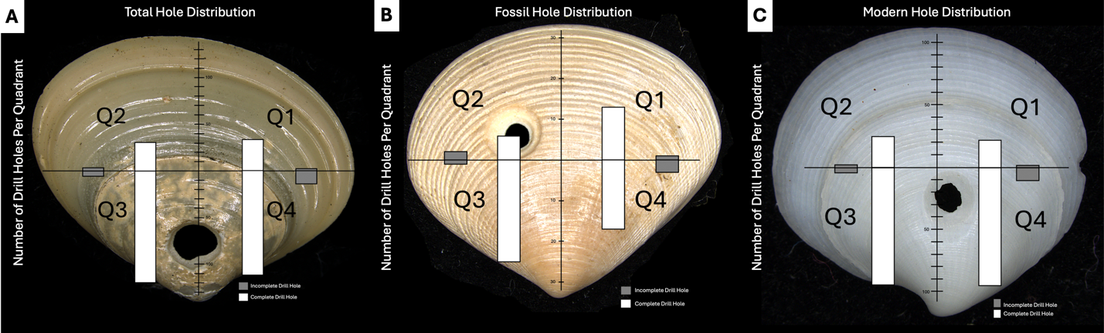
FIG. 3.— Incomplete and complete drill hole distribution on valves categorized into quadrants are modeled for the total drilled specimens, fossilized drill specimens and modern drilled specimens. The number of complete and incomplete drill holes recorded in quadrants are represented by bars projected onto specimens represented in the data set.
Drill attempts in quadrant one were incomplete 6% of the time across all specimens (Fig. 3A). In fossil specimens, 7% of drill attempts in quadrant four were incomplete drill holes (Fig. 3B). Modern specimens observed incomplete drill holes as 5% of the total drill attempts in quadrant four (Fig. 3C). Out of the total drill attempts in quadrant two, 12% of them were incomplete drill holes (Fig. 3A). 25% of the drill holes in quadrant two of fossilized specimens were incomplete (Fig. 3B), and 8% of the drill holes in quadrant two of modern specimens were incomplete (Fig. 3C). Quadrant three had 5% of the total drill holes in the quadrant be incomplete (Fig. 3A). Fossilized specimens had 4% of drill holes in quadrant three as incomplete (Fig. 3B), and modern specimens had 5% of drill holes in quadrant three be incomplete (Fig. 3C). 11% of total drill holes in quadrant four were incomplete (Fig. 3A). In fossilized specimens, 18% of drill holes were incomplete in quadrant four (Fig. 3B), and 10% of drill attempts in quadrant four of modern specimens were incomplete (Fig. 3C).

DISCUSSION
The size of gastropod predators correlates to the size of bivalve predators. This is seen in Figure 2 as the diameter of drill attempts generally increases with the lengths and widths of bivalves. This trend supports the hypothesis that larger gastropods will prey on larger bivalves and smaller gastropods will prey on smaller bivalves. The result of this study upholds trends seen by Grey (2002) in Euspira lewisii and Euspira heros drill holes. Overall, the study shows a positive correlation of size between predators and their prey in gastropod drilling predation of bivalves. The relationship observed between bivalves and gastropods in this study represents a broader trend in predator-prey relationships of larger predators choosing larger prey and smaller predators consuming smaller prey.
Furthermore, the relationship between gastropod predator size and bivalve prey size was logarithmic, disproving the original hypothesis that predator size would be directly proportional to prey size (Fig. 2). The results from Figure 2 show that the predator-prey size ratio between gastropods and bivalves increases as prey size decreases. While this study examined size of prey and size of predators based on length, widths and drill hole diameter, broader studies on predator-prey relationships conclude that as the body mass of predators increases, the predator-prey body mass ratio increases (Barnes et al. 2010). These studies show that as predator size increases, prey size increases at a slower rate. The logarithmic relationship seen in this experiment may be attributed to the energy it takes predators to capture and consume prey compared to the energy a predator receives from the prey. Portalier et al. (2019) found that carnivores may consume smaller prey as a result of the capture process. The logarithmic trend seen in this experiment represents a broader trend of predators consuming prey for a net gain in energy (Portalier et al. 2019). As bivalves increase in size, their shells will typically increase in thickness (Fan et al. 2007). Larger gastropods may prey on smaller gastropods due to the increased energy consumed in the drilling predation of thicker valves.
The majority of drill holes in all sample pools (total, fossil and modern) occurred in the quadrants closest to the hinge of valves (Fig. 3)— many holes were found directly on the hinges of valves. These observations disprove the original hypothesis as drill holes were not typically found in the center of valves but instead found closer to the hinge of the valve. However, the hypothesis that gastropods drill near the soft organs is satisfied as the soft organs of bivalves occupy more space in the half of the valve nearest to the hinge compared to the half of the valve furthest from the hinge (Allmon and Mikkelsen 2020). This trend infers that gastropods intentionally drill in the bottom half of valves to consume the soft organs of valves with maximum efficiency.
Quadrant one of fossilized specimens had less than a 10% difference in drill holes than quadrant four of the same sample pool (Fig. 3B). This trend was not consistent with the total sample pool or the modern sample pool where quadrants one and two had almost 30% less drill holes than both quadrants three and four (Figs. 3A, 3C). The fossilized sample pool was marginally smaller than the other two sample pools, so additional fossilized drilled specimens would be required to further evaluate this trend. Pallial lines on the interior of the shell represent the attachment of soft organs (Allmon and Mikkelsen 2020). Future evaluation of pallial lines on a larger sample pool of fossilized and modern specimens could provide insight into morphological changes to the internal structure of bivalves accounting for the increase in quadrant one drill holes. Pallial lines occupying more space in the half of the valve furthest from the hinge in fossilized valves compared to in modern valves could explain the trend observed in this study.
Overall, incomplete drill holes were observed in similar percentages among quadrants. In the total and modern sample pools, the percentages of incomplete drill holes in quadrants differed by less than 10% among all quadrants (Figs. 3A, 3C). In fossilized specimens, quadrants four and two had greater than 10% the amount of incomplete drill holes in their quadrants than quadrant three (Fig. 3B). Quadrant two also had over 10% the amount of incomplete drill holes than quadrant one had (Fig. 3B). The difference in the fossilized trend compared to the modern trend could be attributed to the lack of drilled fossilized specimens. However, among all sample pools, quadrants two and four had higher incomplete drill hole percentages than quadrants one and three (Fig. 3). As similar percentages of incomplete drill holes were observed in all quadrants, this observation may be the result of an overall small sample size as only 19 incomplete drill holes were observed among the sample pool.
In conclusion, drilling predation between gastropods and bivalves reflects larger trends seen in predator-prey relationships: larger predators prey on larger prey than smaller predators and as predators get larger they consume both larger and smaller prey. Gastropods also likely maximize the efficiency of drilling predation by drilling nearest to soft organs in the half of the valve near the hinge. Similarly, drill location has little effect on whether drill holes are complete or incomplete.

ACKNOWLEDGEMENTS
I would like to express my gratitude to Erynn Johnson, Eric Lazo-Wasem, Lourdes Rojas, Jessica Utrup, and David Skelly for their feedback and assistance throughout this study. This study would not have been possible without the specimens and equipment provided by the Yale Peabody Museum’s Invertebrate Zoology and Invertebrate Paleontology collections.

REFERENCES
ALLMON, W.D., and MIKKELSEN, P.M., 2020, Bivalvia: The Digital Encyclopedia of Ancient
Life, updated February 14, 2022,
https://www.digitalatlasofancientlife.org/learn/mollusca/bivalvia/. Checked December
2024.
BARNES, C., MAXWELL, D., REUMAN, D.C., and JENNINGS, S., 2010, Global patterns in
predator–prey size relationships reveal size dependency of trophic transfer
efficiency: Ecology (Durham) 91 (1): 222-232.
BROWN, K. M., and ALEXANDER, J.E., JR., 1994, Group foraging in a marine gastropod
predator: benefits and costs to individuals: Mar. Ecol. Prog. Ser. 112 (1/2): 97-105.
CARRIKER, M. R., and GRUBER, G.L., 1999, Uniqueness of the gastropod accessory boring
organ (ABO): comparative biology, an update: J. Shellfish Res. 18 (2):579-595.
DIETL, G. P., 2000, Successful and unsuccessful predation of the gastropod Nucel la lapillus
(Muricidae) on the mussel Mytilus edulis from Maine: The Veliger 43(4):319-329.
FAN, D., ZHANG, A., YANG, Z., SUN, X., 2007, Observations on shell growth and morphology
of the bivalve Ruditapes Philippinarum: Chinese Journal of Oceanology and Limnology 25
(3): 322-329.
GREY, M., 2002, Predator-prey relationships of naticid gastropods and their bivalve prey:
ProQuest Dissertations & Theses.
HARPER, E. M., FORSYTHE, G. T. W., and PALMER, T., 1998, Taphonomy and the
Mesozoic marine revolution: preservation state masks the importance of boring predators: Palaios 13 (4):352-360.
KELLEY, P.H. AND HANSEN, T.A., 2003, The fossil record of drilling predation on bivalves
and gastropods, in P.H. Kelley, M. Kowalewski, and T.A. Hansen (eds.), Predatory-Prey
Interactions in the Fossil Record: Kluwer Academic/ Plenum, New York, p. 113–139.
KITCHELL, J. A., BOGGS, C. H., KITCHELL, J. F., and RICE, J. A., 1981, Prey selection by
naticid gastropods: experimental tests and application to the fossil record: Paleobiology
7 (4):533-552.
KITCHELL, J. A., BOGGS, C. H., RICE, J. A., KITCHELL, J. F., HOFFMAN, A., and MARTINELL,
J., 1981, Anomalies in naticid predatory behavior: a critique and experimental
Observations: Malacologia 27 (1986): 291-298.
KOWALEWSKI, M., 2004, Drill holes produced by the predatory gastropod Nucella lamellose
(Muricidae): palaeobiological and ecological implications: Journal of Molluscan Studies 70 (4): 359-370.
NEWTON, C. R., 1983, Triassic origin of shell-boring gastropods: Geol. Soc. Am. Abstr. Progr.
15 (6):652-653
PORTALIER, S. M. J., FUSSMANN, G.F., LOREAU, M., CHERIF, M., and SIEPIELSKI, A., 2019,
The mechanics of predator–prey interactions: first principles of physics predict predator
prey size ratios: Functional Ecology 33 (2): 323-334.

